**Towns in Connecticut with Healthy Lifestyle**

Isha Sodhi

14th Sep 2020

**1. INTRODUCTION**

**1.1 Description of the problem**

There are always ups and downs in the real estate market. However, following the occurrence of the pandemic, a new trend is being observed among the people looking for their new home- 'Healthy Lifestyle and healthy neighborhood'. Home hunters are now looking for a home in a town/city where they can enjoy the nature as well as stay fit by involving themselves in different activities. They want to buy a home in a neighborhood which gives plenty of different options to have an active lifestyle. As social distancing has become the need of the hour, people are preferring more open ground activities, rather than those inside closed rooms.

Real estate agents in Connecticut need the help of data science to present the neighborhoods to their customer which have different healthy activities around, like state parks for hiking, trails, farmers market for fresh food, beaches for recreation.

**1.2 Solution**

In this project, I'll be using my knowledge of data science to analyze which towns/cities in Connecticut state have more number of venues that the real estate agents are currently interested in, viz. state parks, playgrounds, beaches, farmers markets, yoga studios etc.

To start with, I'll need the town/city data of Connecticut, analyze the data and find clusters of towns/cities in Connecticut having more number of venues of interest. Clustering method will help me achieve the required clusters.

**2. DATA**

**2.1 Source**

The data of list of Towns & Cities will be downloaded from Wikipedia: <https://en.wikipedia.org/wiki/List_of_towns_in_Connecticut> .

**2.2 Description**

The list on Wikipedia gives the table along with list of towns, population of towns, their respective counties, land area, designation, Council of governments. For this project, many of the columns will be dropped which will not contribute to the solution. Wrangling of data will be done in order to filter out the unnecessary data. The main column that we are focused on is the 'Town', which will be used to obtain the geo-coordinates.

Table 1: Raw data from Wikipedia

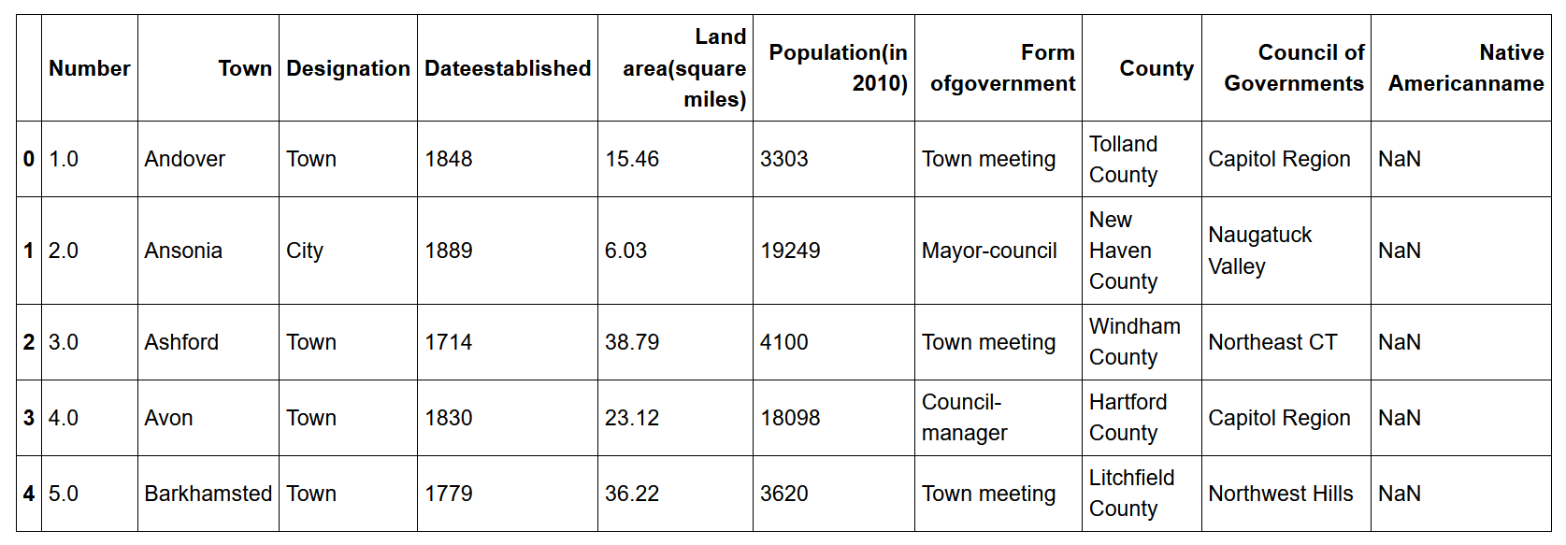

The unwanted columns were dropped, and a new table was created using the wrangling functions available in python.

Table 2: Cleaned Data

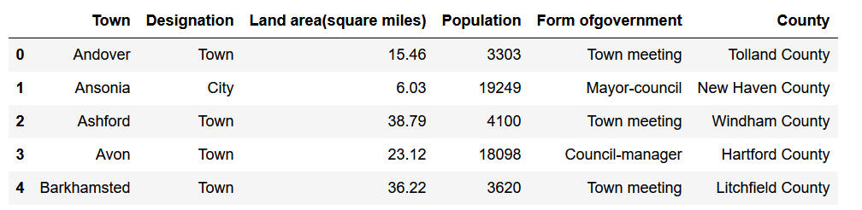

Coordinates of the towns will be collected using the geocoder package and these coordinates will be used in the foursquare application to find out the venues of interest.

Table 3: Coordinates obtained using geocoder

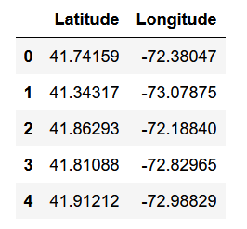

The two above tables were merged together to get a better idea of which coordinates corresponds to which Towns.

The data obtained from foursquare will provide the information of all different types of venues in all the towns of Connecticut. Our aim is to filter the venues of interest i.e parks, farmer's markets, beaches, yoga studios, gyms. All these venues contribute towards a healthy lifestyle.

**3. METHODOLOGY**

**3.1 Analysis of data**

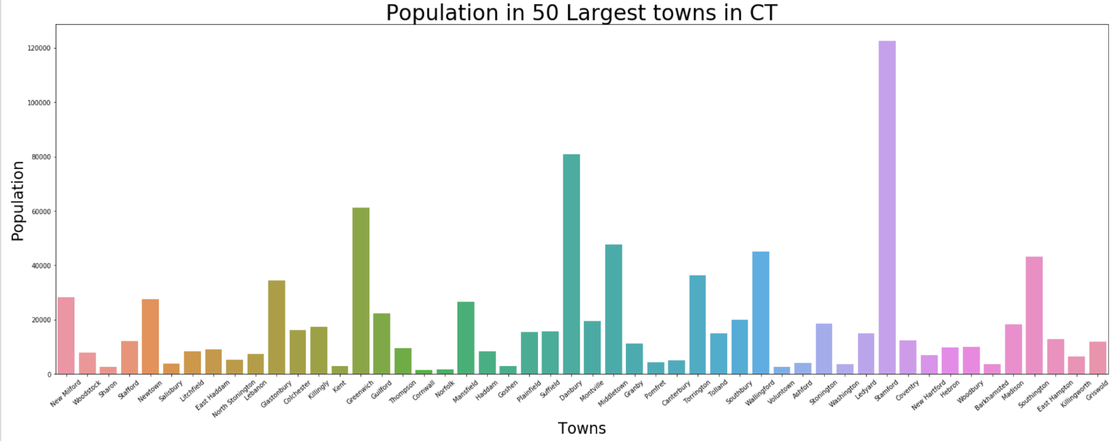

With the help of plots, data is analyzed to find relation between different factors that can contribute to our solution. I started with observing the population of different towns in Connecticut and plotted 50 most populous towns. The aim is to find if there is any relation between land area, population and the venues that we are considering.

It was observed that Stamford was the most populated town of Connecticut, followed by Danbury, Greenwich and Southington.

Further, I plotted a scatter plot of population verses the land area. One would think that larger land area should correspond to more population; however, no specific relation was observed between these two factors. This would give us an idea that there would be non-residential land in towns with larger land area; the reason could be the town has more state parks, playgrounds, theme parks or it would have more industries, malls etc.

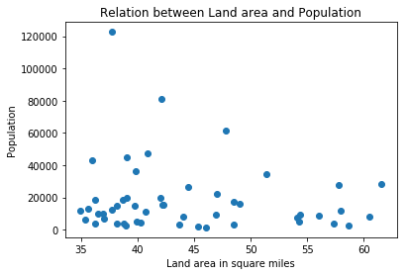

**3.2 Visualization of Coordinates**

Folium is a powerful python library that makes it easy to visualize the data in the form of an interactive map. In this project I used folium.Map function to get a map of Connecticut with marked coordinates. We can zoom in and out as per our need and when the mouse pointer is hovered over the marked coordinate, it shows the name of the town.

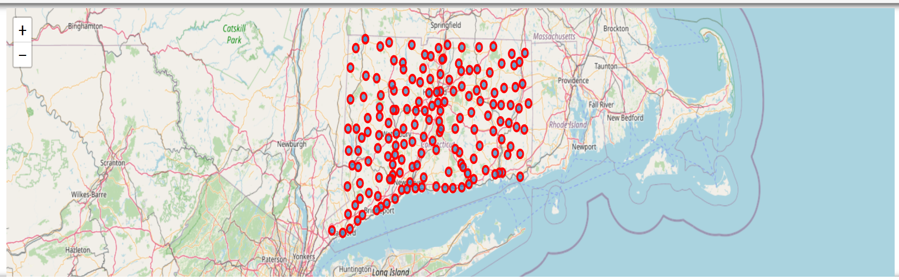

Map of Connecticut with marked Coordinates

**3.3 Use of Foursquare**

As we are interested in specific type of venues viz. state parks, beaches, gyms, outdoor activity venues we will have to use an API which can provide us with the data of the interested venues in Connecticut. I’ve taken the advantage of having an account with FourSquare API to get the required data.

Different types of calls can be made on FourSquare but as the numbers of calls per day are limited, I’ve set the ‘Limit’ to 100.

There is another variable which is very important to raise a call with FourSquare, to get proper data: Radius. It decides the range in which the API will search for the interested Venues and will provide the venues within that range. Generally, the center point is the downtown of that particular town. Initially, I had set the radius as 500, which did not give me enough data to work on as I’m focused on a limited number of venue categories. With trials I found the appropriate radius to be 5000.

Raw data obtained from FourSquare had a total of 361 unique categories. After scanning the different categories, the following were chosen for this project:

* Athletics & Sports
* Campground
* Cycle Studio
* Dance Studio
* Fair
* Farmers Market
* Gym
* Gym/Fitness Center
* Gym Pool
* Gymnastics Gym
* Harbor/Marina
* Lake
* Monument/Landmak
* Paintball field
* Park
* Playground
* River
* State/Provincial Park
* Theme Park Ride / Attraction
* Trail
* Yoga Studio

**3.4 Analysis of FourSquare Data**

Since the data returned by FourSquare was huge, some filtering was needed. Only the towns which had more than 5 venues of interest were extracted and a table was formed. The top 10 towns with most venues of interest is shown in table below:

Table 3: Coordinates obtained using geocoder

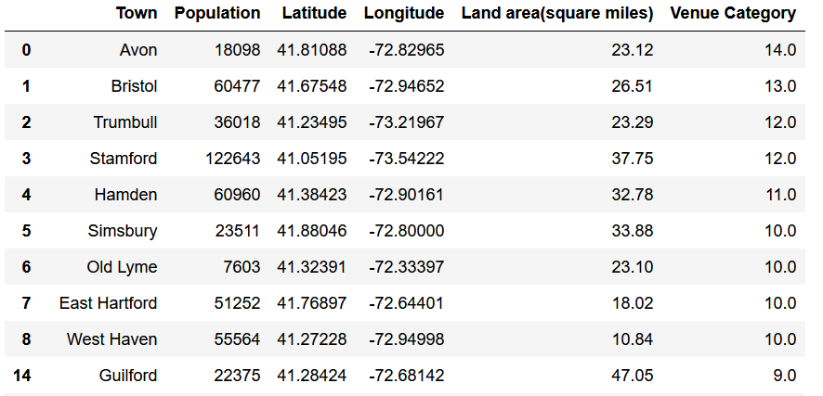

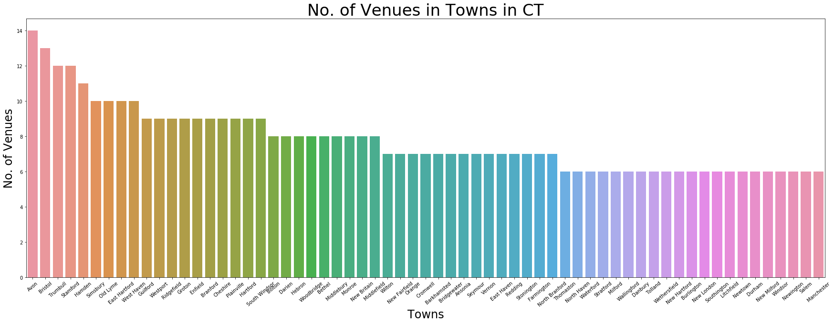

**3.5 One hot encoding**

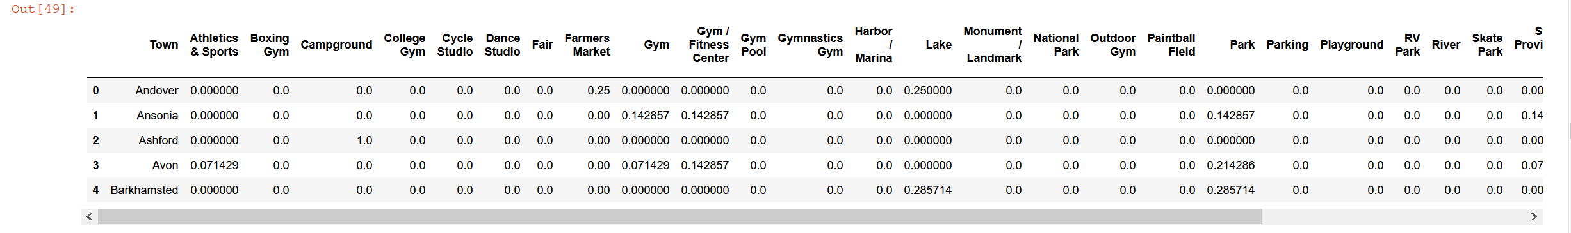

**3.6 Clustering**

**Finding suitable value of 'k': Elbow Method**

Clustering method requires to define the value of ‘k’ which decides how many clusters will be formed. For selecting a proper ‘k’ Elbow method is used. The value that I found to be appropriate was 5.

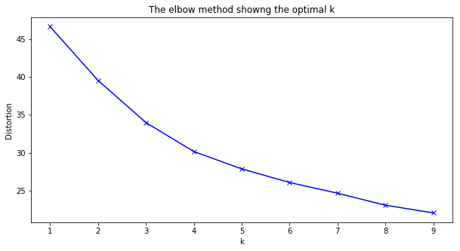

**4. RESULTS**

Total 5 clusters were obtained as k-clustering method was used.

**Cluster0**: This cluster has total of 25 Towns and the most common venues include Gym and fitness centers. The venue categories had different names for these types of venues as listed above. The Majority of the venues were gym and fitness center and a few of trails and parks.

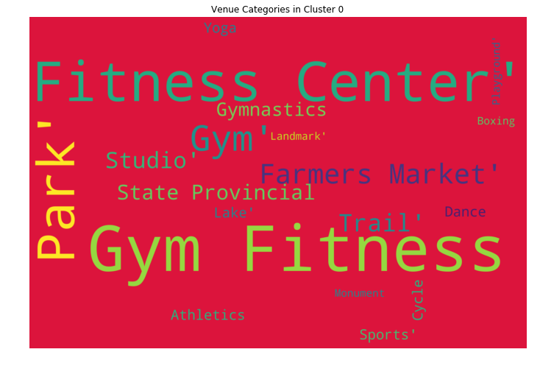

**Cluster1**: This cluster has total of 31 Towns and the most common venues include Trails, Parks and Lakes. The venue categories had different names for these types of venues as listed above. The Majority of the venues in this cluster were open ground recreational venues and a few of gyms and studios.

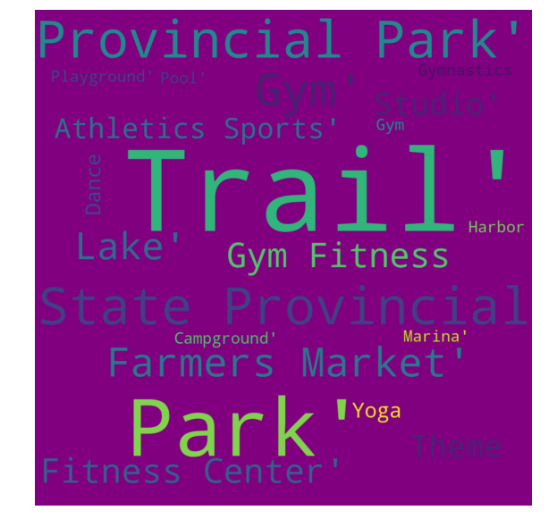

**Cluster2**: This cluster has total of 33 Towns and the most common venues include Campground, Harbor marina and Lakes. The venue categories had different names for these types of venues as listed above. The Majority of the venues in this cluster were open ground/water recreational venues and a few of fitness centers.

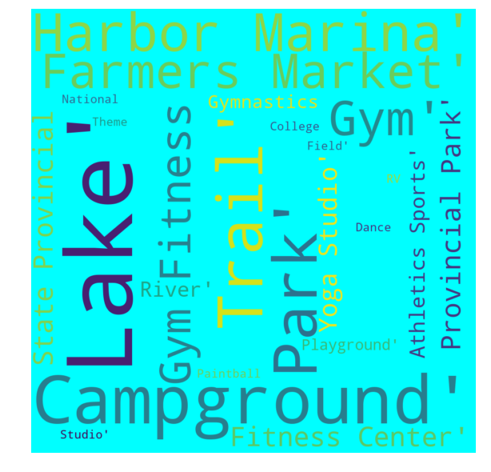

**Cluster3**: This cluster has total of 37 Towns and the most common venues include Farmers Market, Parks and Theme parks. The venue categories had different names for these types of venues as listed above. The Majority of the venues in this cluster were open ground recreational venues and a few of gyms and studios.

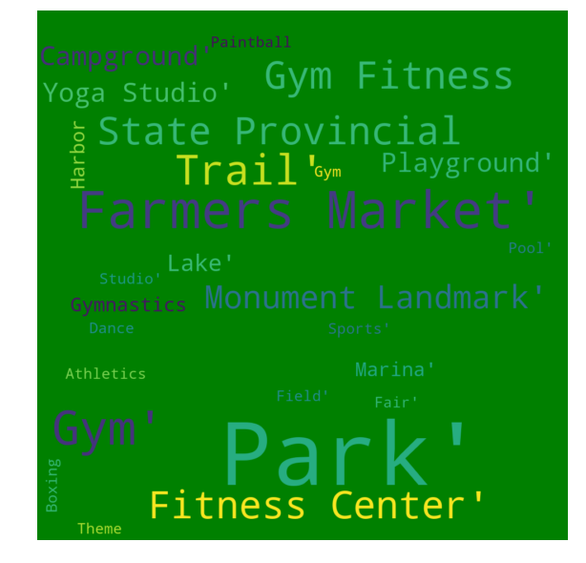

**Cluster4:** This cluster is a combination of Gym, Parks and Fitness centers as the most common venues followed by yoga studios, playgrounds, and farmers markets.

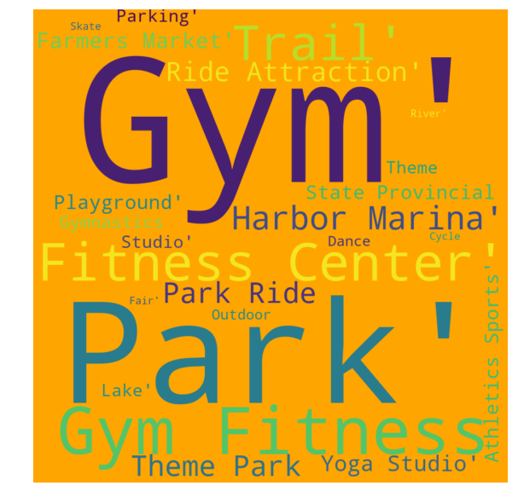

**5. DISCUSSION**

From the above results I’ve observed the clusters are formed which has similar venues:

Cluster0- Gym & fitness centers

Cluser1- Open ground activity venues

Cluster2- Water venues

Cluster3- Farmers’ Market and theme parks

Cluster4- Combination of Gyms & Parks

The below table shows the towns in each cluster:

|  | **Towns_C0** | **Towns_C1** | **Towns_C2** | **Towns_C3** | **Towns_C4** |
| --- | --- | --- | --- | --- | --- |
| **0** | Beacon Falls | Ansonia | Andover | Bethany | Berlin | |
| **1** | Bethel | Avon | Ashford | Bridgeport | Bristol | |
| **2** | Branford | Barkhamsted | Bozrah | Bridgewater | Brookfield | |
| **3** | Cromwell | Bethlehem | Canaan | Cheshire | Canton | |
| **4** | Derby | Bloomfield | Chaplin | Colchester | Clinton | |
| **5** | Farmington | Bolton | Chester | Danbury | Darien | |
| **6** | Granby | Burlington | Columbia | Deep River | Durham | |
| **7** | Griswold | Colebrook | Coventry | East Haven | East Hartford | |
| **8** | Manchester | Cornwall | East Granby | Ellington | East Windsor | |
| **9** | Meriden | Easton | East Haddam | Groton | Enfield | |
| **10** | Newington | Hartland | East Hampton | Haddam | Essex | |
| **11** | Newtown | Kent | East Lyme | Hebron | Fairfield | |
| **12** | North Branford | Lebanon | Eastford | Ledyard | Franklin | |
| **13** | Norwich | Litchfield | Goshen | Lisbon | Glastonbury | |
| **14** | Orange | Lyme | Killingworth | Madison | Greenwich | |
| **15** | Plainville | Mansfield | Marlborough | Middletown | Guilford | |
| **16** | Putnam | Morris | New Fairfield | Milford | Hamden | |
| **17** | Rocky Hill | Norfolk | New Hartford | Montville | Hartford | |
| **18** | Shelton | North Haven | North Canaan | Naugatuck | Harwinton | |
| **19** | Stratford | North Stonington | Norwalk | New Canaan | Killingly | |
| **20** | Tolland | Pomfret | Old Lyme | New Haven | Middlebury | |
| **21** | Vernon | Preston | Old Saybrook | New London | Middlefield | |
| **22** | Westport | Prospect | Plymouth | New Milford | Monroe | |
| **23** | Wethersfield | Redding | Ridgefield | Oxford | New Britain | |
| **24** | Wolcott | Roxbury | Salem | Portland | South Windsor | |
| **25** | NaN | Seymour | Salisbury | Scotland | Stonington | |
| **26** | NaN | Simsbury | Southbury | Sherman | Suffield | |
| **27** | NaN | Washington | Thomaston | Somers | Torrington | |
| **28** | NaN | Weston | Thompson | Southington | Wallingford | |
| **29** | NaN | Woodbridge | Trumbull | Sprague | Watertown | |
| **30** | NaN | Woodbury | Union | Stamford | Westbrook | |
| **31** | NaN | NaN | Willington | Sterling | Wilton | |
| **32** | NaN | NaN | Winchester | Voluntown | Windham | |
| **33** | NaN | NaN | NaN | Waterbury | Windsor | |
| **34** | NaN | NaN | NaN | Waterford | Windsor Locks | |
| **35** | NaN | NaN | NaN | West Hartford | Woodstock | |
| **36** | NaN | NaN | NaN | West Haven | NaN | |

As the size of each cluster varies, the empty cells are filled with NaN.

**6. CONCLUSION**

**Based on the above results and discussions, I would recommend a home finder to choose a town from cluster4. This cluster offers mostly all the venues of interest. However, if someone is interested in gym and fitness centers as compared to other venues, they can select cluster0.**

**The above results and discussions will be very helpful to the real estate agents to provide suggestions to their clients and support their suggestions with the facts and figures of this report.**